Zack Chambers

CST 221

John Zupan

February 3, 2019

GitHub Link:

**File Systems**

**Directories**

|  |  |
| --- | --- |
| **Directory** | **Purpose** |
| / | The root directory of the file system. This is the base of any directory. |
| /bin | The bin directory contains basic command binaries. For example ls, cat, etc. |
| /dev | The dev directory contains device files. These can be interfaces to drivers. |
| /etc | The etc directory contains configuration files specific to a host. This originally held files that did not fit in other directories but has been repurposed. |
| /lib | The lib directory contains libraries for the bin directory. Libraries are collections of behavior that can be re-used by programs. These have a well-defined interface. |
| /boot | The boot directory contains files to start the system. These files can be used to start the kernel or other processes. |
| /home | The home directory contains user files. These can be saved files or personal settings. |
| /mnt | The mnt directory contains temporarily mounted filesystems. Mounted files are files made available through the filesystem. |
| /proc | The proc directory is a virtual filesystem that provides kernel and process information as files. This is normally automatically generated by the system. |
| /tmp | The tmp directory contains temporary files. This generally is restricted in size and does not survive a system reboot. |
| /usr | The usr directory contains read-only user data. It houses the majority of multi-user applications. |
| /var | The var directory contains variable files. These files are expected to constantly change. |
| /sbin | The sbin contains system command binaries. One such command would be init. |
| /kernel | Though I can’t find anything in ubuntu or online about /kernel, I would think this would contain configuration files for the kernel. |

**Ubuntu Directories**

|  |  |
| --- | --- |
| **Directory** | **Purpose** |
| /bin | The bin directory contains basic command binaries. These can be ls, cat, etc… |
| /boot | The boot directory contains files to start the system. These files can be used to start the kernel or other processes. |
| /cdrom | The cdrom directory contains files used to mount cds. |
| /dev | The dev directory contains device files. These can be interfaces to drivers. |
| /etc | The etc directory contains configuration files specific to a host. This originally held files that did not fit in other directories, but has been repurposed. |
| /home | The home directory contains user files. These can be saved files or personal settings. |
| /lib | The lib directory contains libraries for the bin directory. Libraries are collections of behavior that can be re-used by programs. These have a well-defined interface. |
| /lib64 | The lib64 directory cocntains the 64-bit versions of the libraries. |
| /lost+found | The lost+found directory contains files that may be lost when a filesystem becomes corrupt. Files that may have been lost are linked via their inode. |
| /media | The media directory contains files for removable media devices. This could include USB drives. |
| /mnt | The mnt directory contains temporarily mounted filesystems. Mounted files are files made available through the filesystem. |
| /opt | The opt directory contains third-party applications that have no dependencies. These are files that don’t need to access files in the usr directory. |
| /proc | The proc directory is a virtual filesystem that provides kernel and process information as files. This is normally automatically generated by the system. |
| /sbin | The sbin contains system command binaries. One such command would be init. |
| /snap | The snap directory holds information files for snaps. Snaps are faster to run, break less, and update automatically. |
| /srv | The srv file holds information to be served. These can be served using www, ftp, etc… |
| /sys | The sys directory is a virtual filesystem. This allows modification of devices connected to the system. |
| /tmp | The tmp directory contains temporary files. This generally is restricted in size, and does not survive a system reboot. |
| /usr | The usr directory contains read-only user data. It houses the majority of multi-user applications. |
| /var | The var directory contains variable files. These files are expected to constantly change. |

**Scenario**

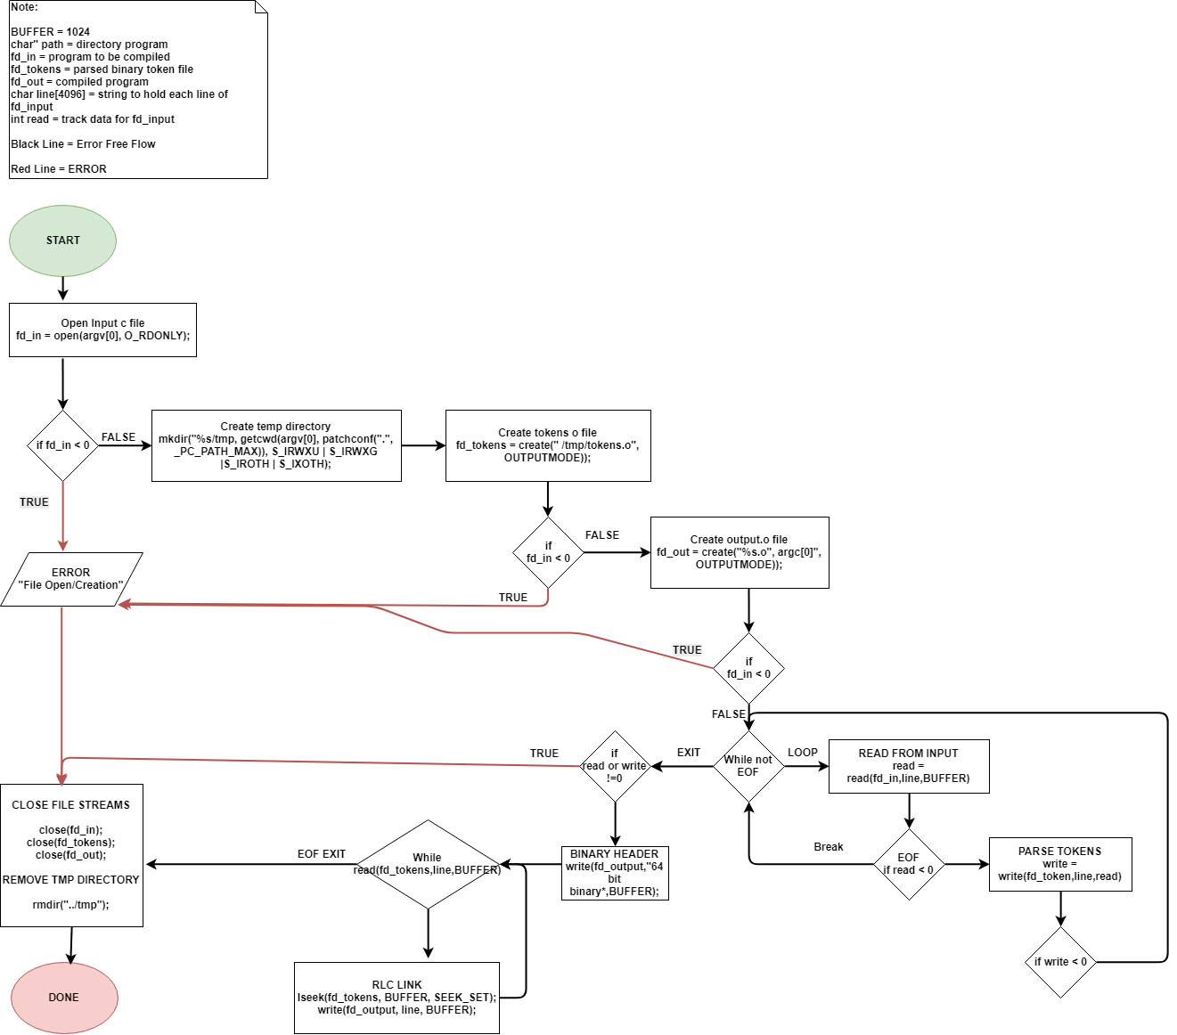

**References**

Tlpd.org. (2018). *Linux Filesystem Hierarchy.* Retrieved from <http://www.tldp.org/LDP/Linux-Filesystem-Hierarchy/html/dev.html>